GUI guides

**Image Correction GUI**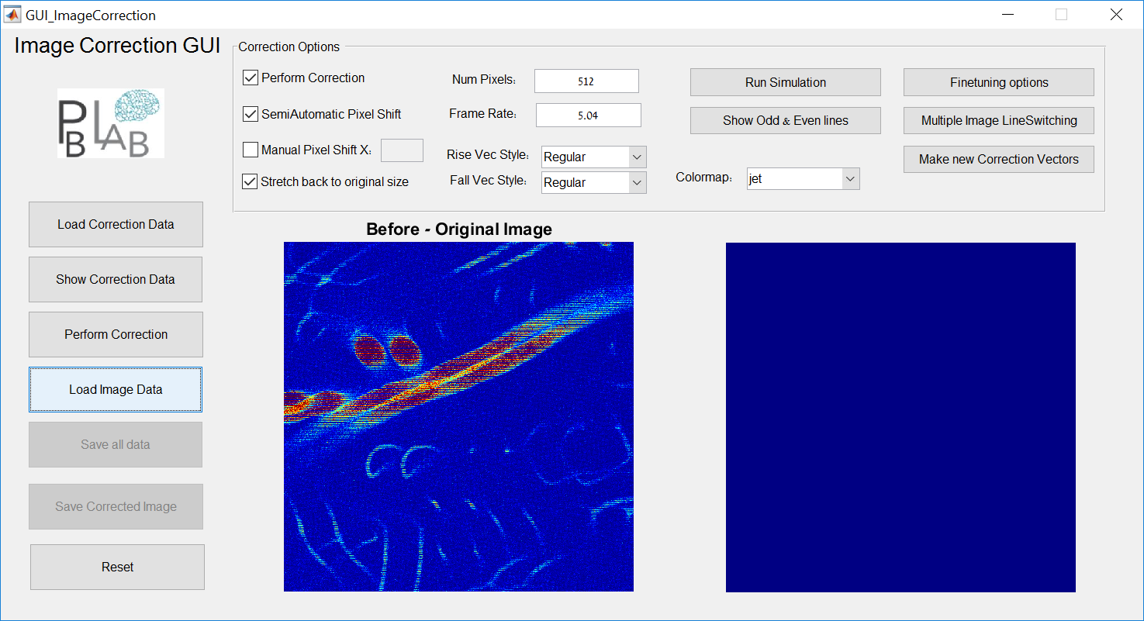

**Left Button Panel:**

**Load Correction** – Open a pre-saved *.mat file containing the data needed for the correction steps. These matrices are created and saved in the Scanning Mirror Function Creator GUI.

**Show Correction Data** – Opens a new figure with the scanning functions, linear functions and corresponding correction vectors both for rise (forward scan) and fall (backward scan):

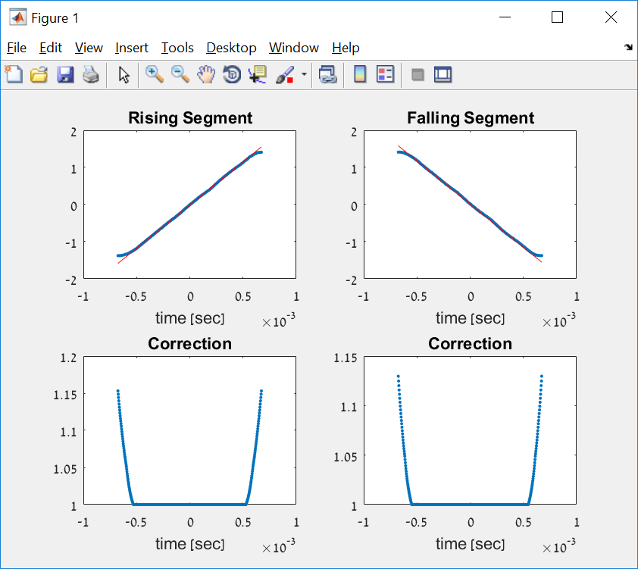

**Load Image Data** – allows the user to select a single image file

**Perform Correction** – Initiates a correction procedure. First a Pixel Shift correction is performed either manually (with the user input in the correction options tab) or semi-automatically using cross-correlation techniques. If the semi-auto option is invoked, then a window of only even lines will open and the user is asked to select a feature for cross-correlation:

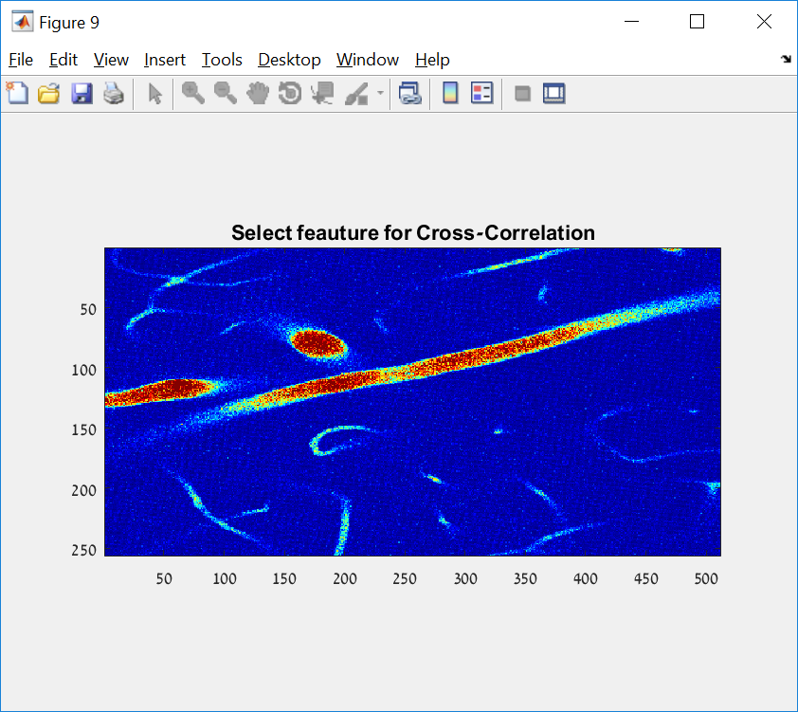

After the feature is selected, the Algorithm will find the best fit, deduce the pixel-shift needed for correction and performs the shift on the image. Then the pixel-shifted image undergoes correction through the correction vectors selected by the user and an output corrected image is displayed on the right:

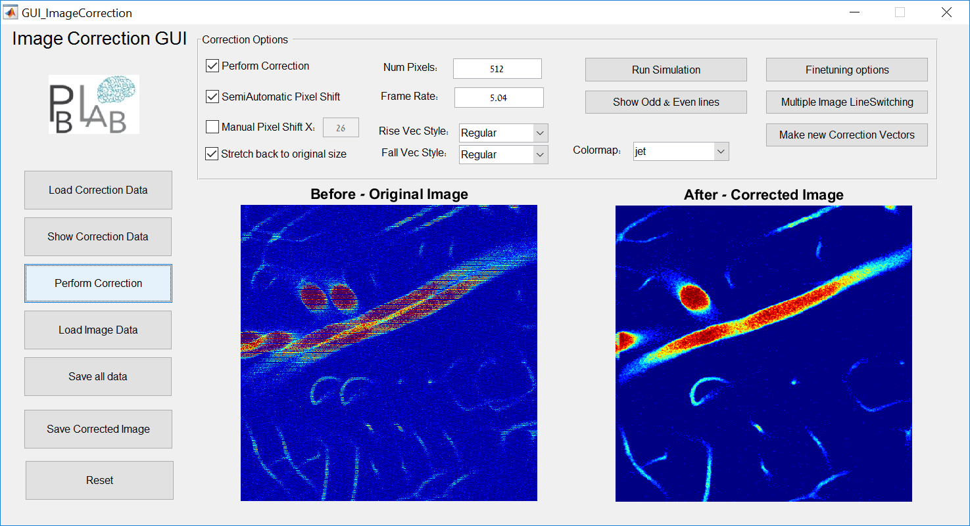

**Save all date –** allows the user to save all images, parameters and correction vectors to a Matlab matrix for futher use.

**Save corrected image –** Saves the corrected image in an image format to a file selected by the user.

**Reset –** Restarts the GUI and cleans all data.

**Correction Options**

**Perform Correction -**  Check if Correction using the input correction vectors is wanted

**SemiAutomatic Pixel Shift –** Check if the user wants to invoke the process which performs cross-corrleation between odd and even lines and finds the best pixel shift match needed. This shift will be displayed in the textbox next to the manual shift option.

**Manual Pixel Shift X –** lets the user input the pixel shift manually.

**Stretch back to original size –** After the correction is done, the image is narrower in size. This option stretches back the image to the original size.

**NumPixels –** number of pixels in each dimension (input optional)

**Frame Rate** – Scanner frame rate (input optional)

**Rise\Fall Vec Style –** allows the user to choose what correction vectors will be used in the correction process, the options are:

Regular – perform threshold & smooth fixes to the calculated correction

Symmetric – Take Rise vector and make a mirror symmetric Fall vector out of it for both rise and fall

Rise+Fall – Take right side from rise and left side from fall for both rise & fall vectors

Raw – Raw correction calculations with no fixes

**Colormap –** select colormap for images shown. Default is jet. Parula and gray are allowed.

**Run Simulation button –** inputs a simulation image for testing

**Show Odd & Even button –** shows the true raster scan image, broken into odd lines (left side) and even lines (right side:

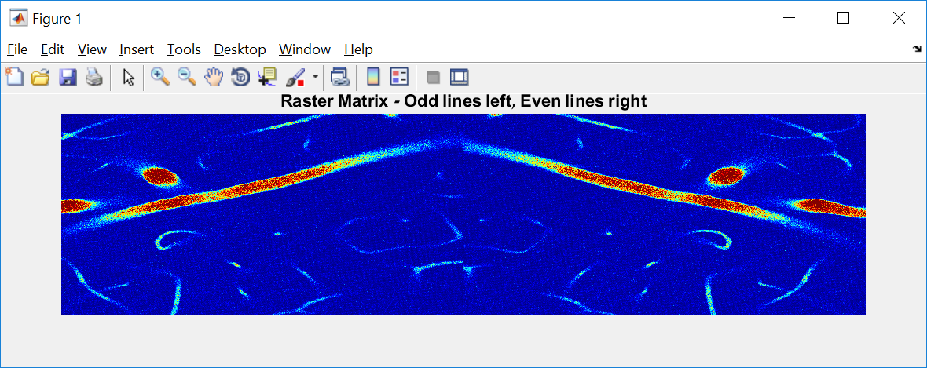

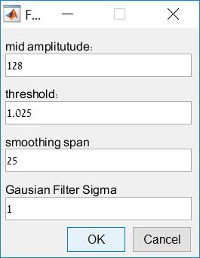**Finetuning options –** opens a window with several options:

Mid amplitude – parameter that affects the fitting and creation of the linear vectors. The parameter decides how many pixels from each side from the middle are taken into account for the liear fit. Default is NumPixles/4.

Threshold – Decides from what correction vector value the output will be 1.

Smoothing Span – span of smoothening filter on the correction vectors.

Gaussian Filter Sigma – option for filtering the output image after all corrections are done.

**Multiple Image Line Switching –** For stacked images, another option of LineSwitching is available through this button

**Make new correction vetors –** Opens the Scanning function Creator GUI

**Scanning Mirror function GUI**

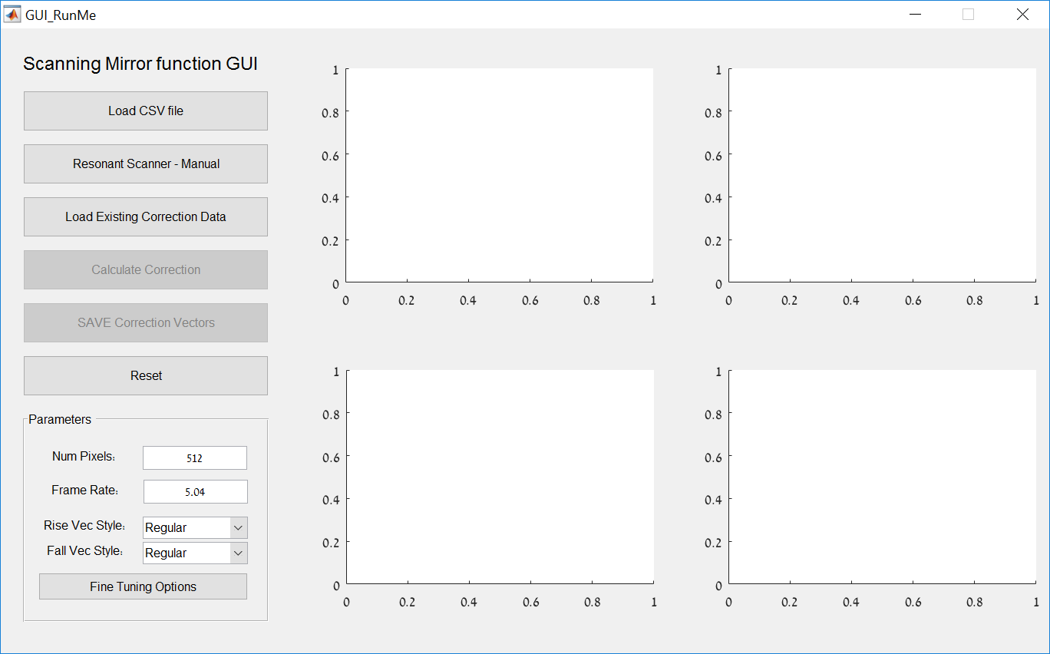

**Load CSV file –** user inputs a CSV file of a scanner. The waveform is

**Resonant Scanner – Manual –** If a fast resonant scanner is used, the there is no need for a CSV file and an option to simulate a sine wave of a given frequency is given.

**Load Existing Correction Data –** allows loading existing data for review

**Calculate Correction –** first, this opens a figure where the user is asked to select a rectangle containing two maximas and one minima

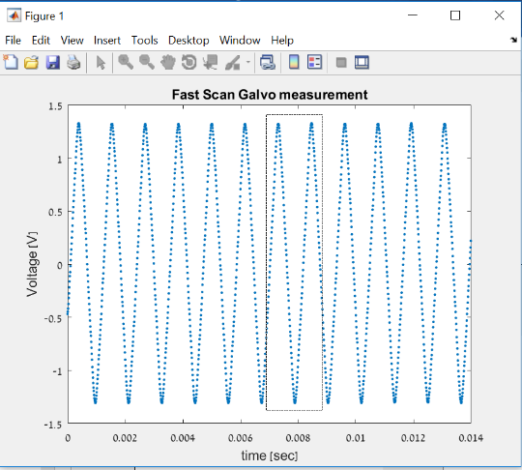

Then, the data for the Rise and Fall vectors is extracted, and a linear fit is performed. These are shown in the 2 upper main figures. Then the correction vector is calculated for vothe rise and fall vectors and shown in the 2 lower main figures.

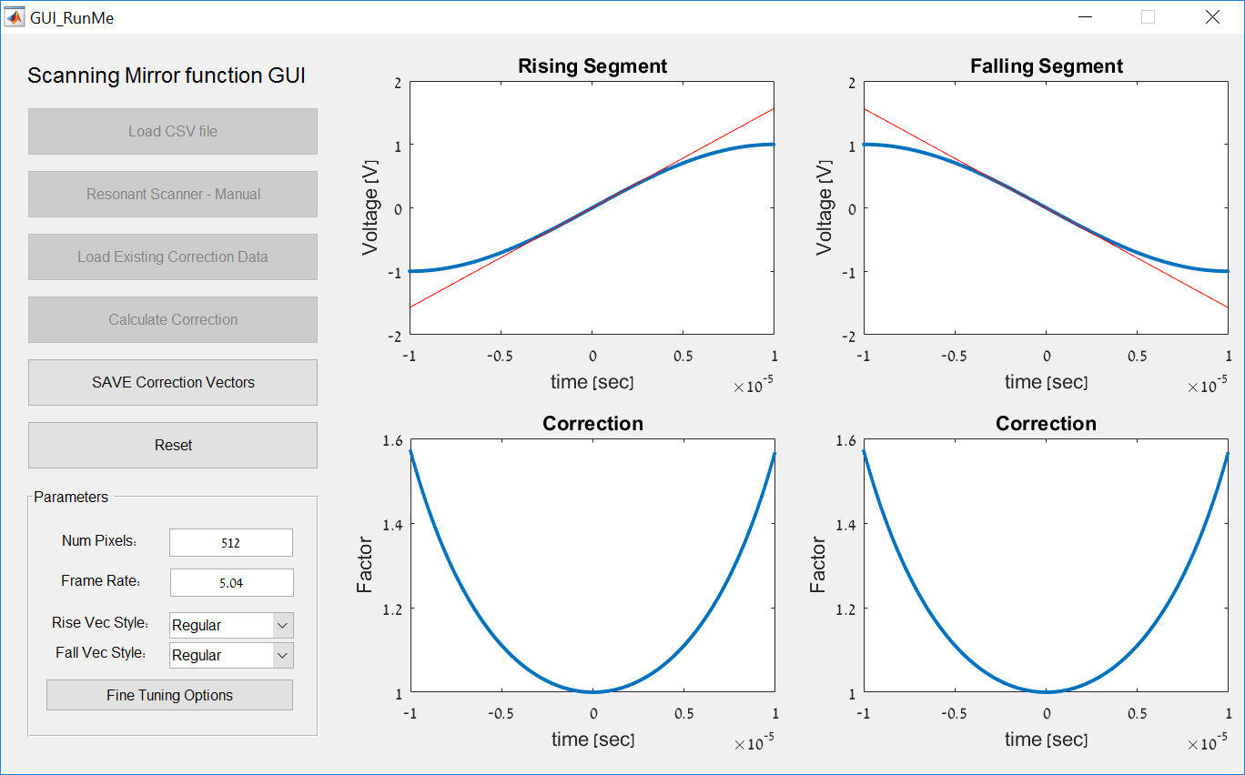

**Save Correction Vectors -**  saves the correction vectors to a *.mat file

**Reset -** clears all and resets the GUI

For Parameters inputs, see explanations in Image Correction GUI